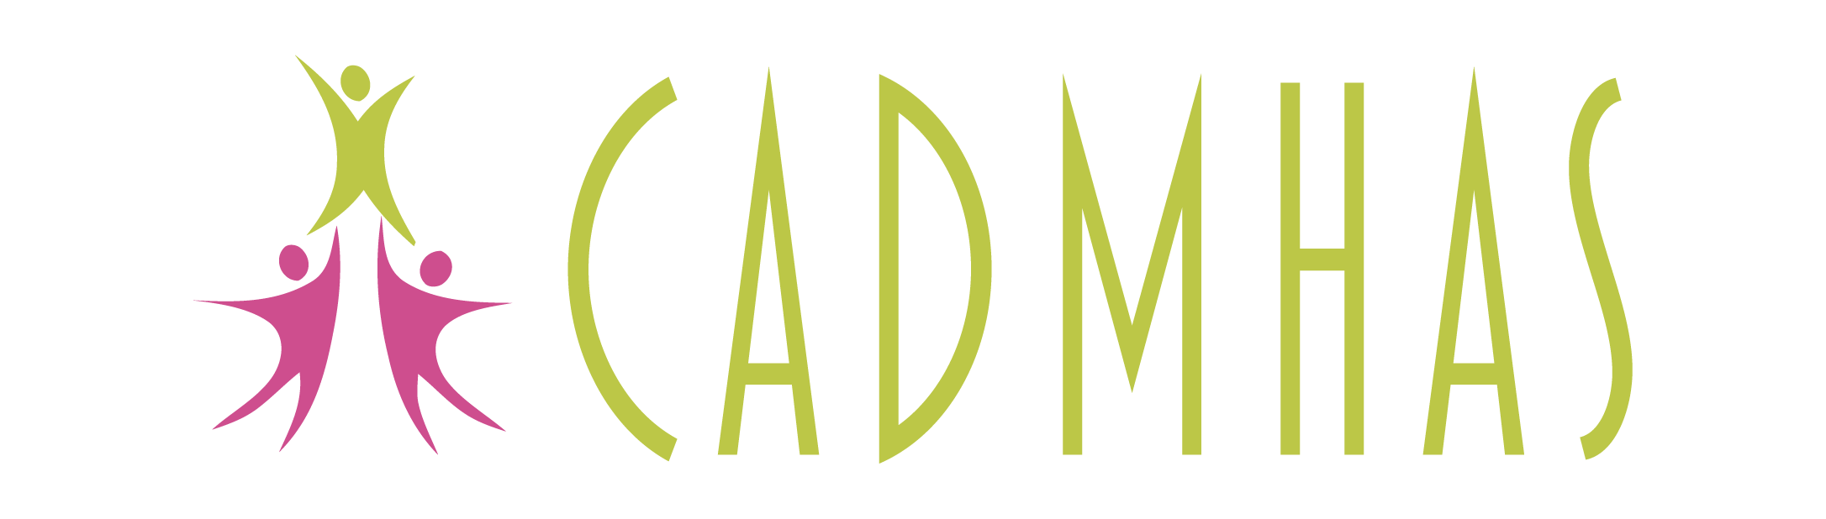
Job Description
Independent Mental Health Advocate (Adult Apprenticeship)
37 hours per week
THE SUCCESSFUL CANDIDATE WILL NEED TO UNDERTAKE THE LEVEL 4 APPRENTICESHIP QUALIFICATION IN INDEPENDENT ADVOCACY
https://www.gcstraining.co.uk/level-4-independent-advocacy-new
CADMHAS has been operating since 2007 and provides community advocacy, statutory advocacy (Independent Mental Health and Independent Mental Capacity Advocacy) and Relevant Person Representative services across North Wales and Powys.
We are looking to appoint an IMHA (Independent Mental Health Advocate) to join our apprenticeship scheme. Our apprenticeship scheme is open to applicants of all ages (over the age of 16) and will require the successful candidate to follow a Level 4 Independent advocacy course (attending college virtually 2 days per month.) The remaining time will be split between completing coursework and practical casework. We are looking for one person to work primarily in Flintshire and Wrexham.

Responsible to: The Principal Advocate, who is responsible to the Director of Services.
Working with: Staff, volunteers, and clients of CADMHAS
Location: Home base – Flintshire and Wrexham
Hours of Work: This post is 37 hours per week
Area of Work: Primarily in Flintshire and Wrexham, but required to work throughout the region to provide cover when required
Aims of the post: To work as a statutory Independent Mental Health Advocate (IMHA) in line with the definition of the role under the Mental Health Act 1983 (as amended, most recently by the Mental Health Act 2007)
Remuneration: The starting salary for the post is £22,287 pro rata per annum, moving to £23,613 pro rata when the Diploma in Independent Advocacy is achieved. The cost of this will be borne by CADMHAS.
CADMHAS will contribute the equivalent of 3% of the salary towards the Government Pension Scheme once the probation period has been completed. Travel expenses and subsistence will be paid in line with CADMHAS agreed rates.
Hours: A full-time working week is 37 hours, this post is for 37 hours per week (excluding lunch hours). Overtime is not payable but time off in lieu may be taken at a mutually convenient time. Very occasional evening and weekend work may be necessary
Annual Leave: Holiday entitlement is 37 days per annum pro rata, inclusive of all Bank Holidays.

There will be a probation period of 3 months commencing from the first day of employment. The post will be subject to an enhanced DBS check
Job Description – Independent Mental Health Advocate

Main duties:
To work as an Independent Mental Health Advocate in Flintshire and Wrexham for CADMHAS. Work will be carried out from a variety of locations as identified by the Director of Services.

This will include:
  - Providing an advocacy service, which is free, independent, and confidential.
  - Ensuring service users are aware of their rights under the Mental Health Act.
  - Providing representation for clients in a wide variety of settings.
  - Supporting clients who wish to represent their own interests.
  - Collecting data and relevant information for the monitoring of the service.
  - Providing balanced information about relevant issues.

The duties outlined above serve as a guide to the major responsibilities of the post. They may need to be reviewed during the lifetime of the post. Any changes will be in consultation with the post holder.

General:
The post holder will be expected to either already hold, or to have achieved within 12 months, the Diploma in Independent Advocacy including the IMHA specialist modules. The post holder will be expected to attend such training events identified as being of value to their role either by the Director of Services or themselves through supervision and appraisal. This post will be home-based with travel to different locations within Flintshire and Wrexham.

Person specification

The following are considered to be essential: -
- An understanding of advocacy
- Understanding of issues faced by people with a mental health problem
- A positive, non-judgmental attitude to, and empathy with, people with mental health problems.
- An understanding of, and commitment to, the involvement and empowerment of those using the Service
- The ability to work in a way that empowers people
- Self-motivated and organised – able to manage your time and carry your caseload
- The ability to communicate effectively with a wide range of people
- The ability to liaise with personnel at all levels of management structures
- Negotiation skills
- The ability to work independently and in conjunction with others
- Report writing/record- keeping skills - Able to write clearly and concisely in letters and reports
- Basic word processing/computer skills/Ability to utilise database
- Car owner / driver.

The following are considered to be desirable: -
- Experience in the field of mental health in a paid/voluntary capacity or as a carer or user of services
- Achieved the Diploma in Independent Advocacy
- The ability to communicate in both Welsh and English
- Experience in advocacy work
- Experience in the voluntary sector

Applications: -
- A CV will not be accepted. Applications forms will need to be requested from CADMHAS office by emailing us at admin@cadmhas.co.uk or by phoning the office on 01745 813999
- Closing date for applications is 3rd March 2023. The applications can be emailed to admin@cadmhas.co.uk or posted to CADMHAS, 94 Bowen Court, St. Asaph Business Park, Denbighshire, LL17 0JE

